RY-YFD 4000 Fully Hydraulic Crawler Composting Turner
The main application & characteristics of the equipment
RY-YFD 4000 fully Hydraulic crawler composting turning machine adopted the advantages of mature model from multi developed countries, combined with China industry conditions to design, with the characteristic of compact design, simple operation, saving working site, etc. The machine winch shaft designed with whole body lifting and lowing , which can lift and adjust the height between the winch and the site to make the operation more convenient when the working site is moved or the turning height needs to be changed.

Main technical parameters: (external dimensions 3400x5300x3900)
The composting turner model | RY-YFD4000 | Rated power (kw) | 194
Turning windrow  width (mm) | 4000 | Maximum torque (N-m)  1338 | 1135
Turning height (m) | 1.9 | Minimum fuel rate (g/kw-h) | ≤231
Track width (m) | 2x0.35 | Diameter of working knife (mm) | 1050
Pile spacing (m) | 0.6 | Maximum processing capacity  (m³/h) | 1596
Maximum material particle (mm) | Φ250 | Number of cylinders | 6
Turning radius (mm) | 2400 | Cylinder volume (L) | 8.3
Forward speed (m/min) | 0-10 | Battery (V) | 12V/150A*2
Backward speed (m/min) | 0-10 | Fuel tank volume (L) | 150
Handling capacity calculation | 7m/min (speed) x 60min (time) x 4m (width) x 1.9m (height) ÷ 2 = 1596 M³ /hour
Engine brand  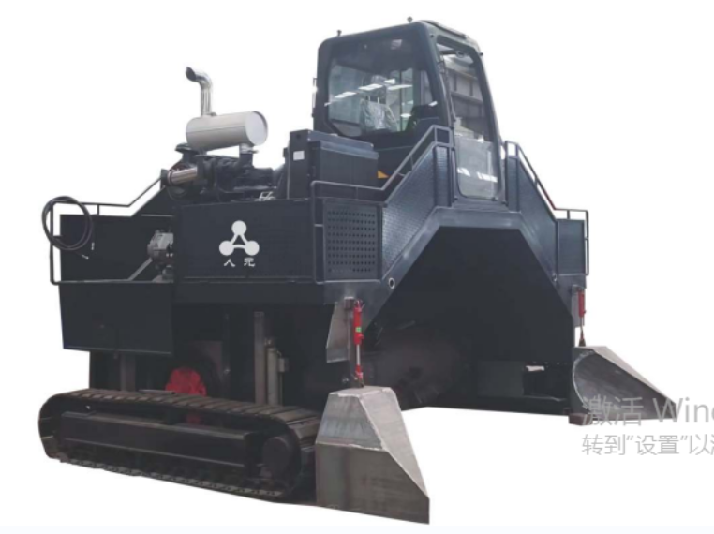 | Dongfeng Cummins 6BTA8.3-C260（Steyr (name)）

